Viewing Chartfield Combinations for Sponsored Projects

When entering Requisitions or completing Requests for Payment, Reports of Travel Expenses, Employee Reimbursement Requests, or IDTs, it is important that you enter the correct sponsored project combination consisting of Business Unit-Department-Product-Account. If you do not, an Invalid Chartfield Combination Error occurs. This guide provides instructions on how to find the correct sponsored combination.

Navigation

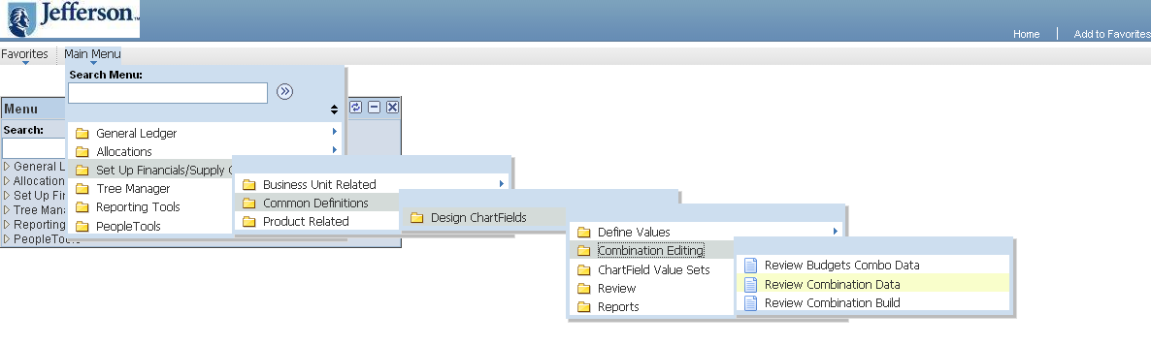
From the Menu Pagelet, click Set up Financials/Supply Chain < Common Definitions < Design Chartfields < Combination Editing < Review Combination Data

Review Combination Data

- At the Review Combination Data page, you will need to enter search criteria. If you want to search for sponsored project combinations, enter Group as: GRANTS_ for TJU or GRANTS081_ for TJH and Department or Product.

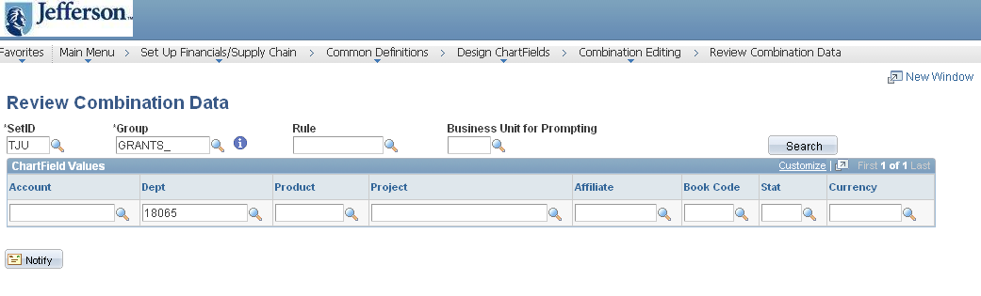
- Click the Search button to display valid sponsored projects.
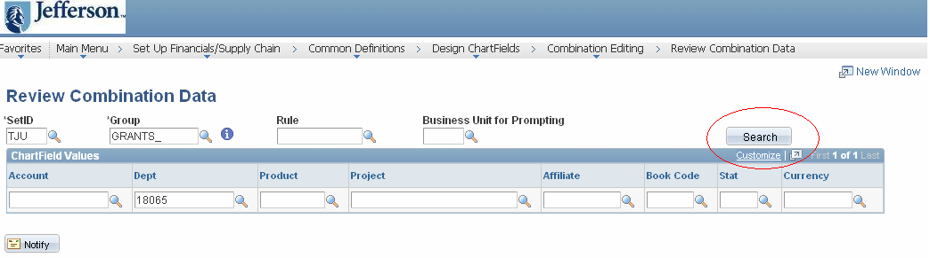

Sample of valid sponsored projects combinations:

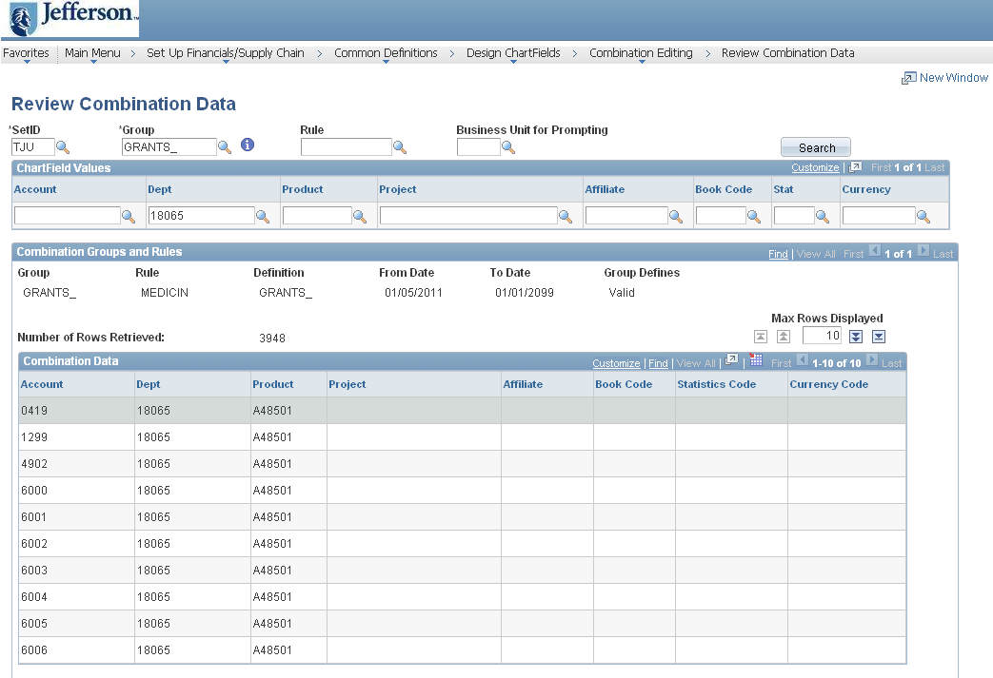

Note: You can further narrow search by entering product or account in Review Combination data section.

