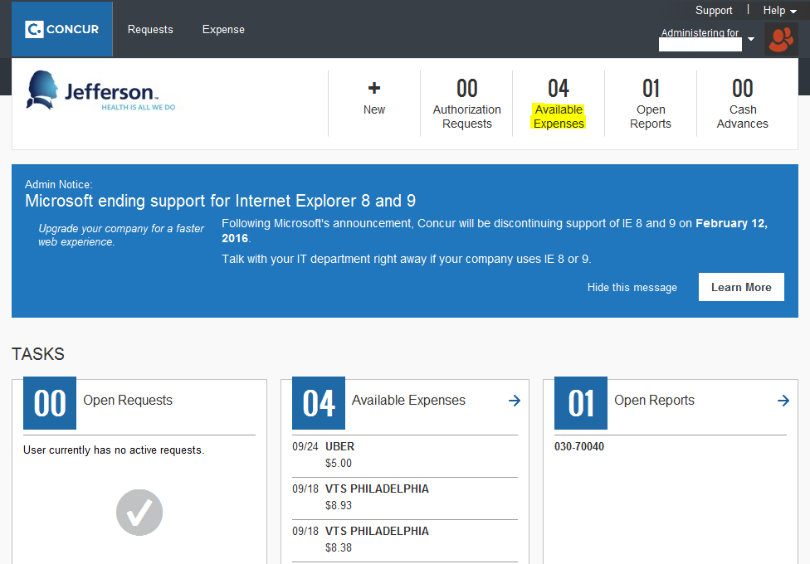
- American Express Corporate Card charges will automatically appear in your Concur profile as Available Expenses.
- Click on Available Expenses to begin creating an expense report to reconcile card charges.
  - 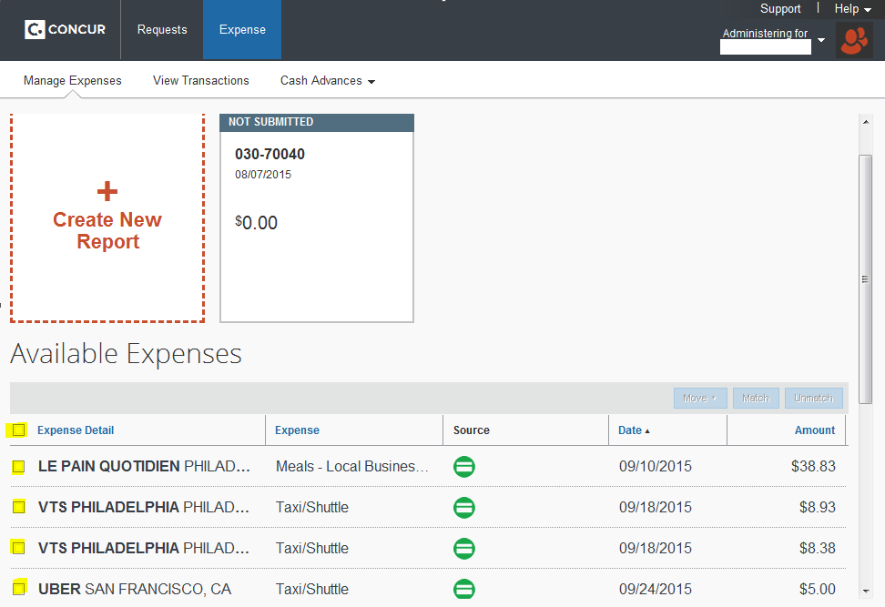
- Select the American Express card charges you wish to add to your expense report by clicking the box to the left of each expense (click the box to the left of Expense Detail to select all).
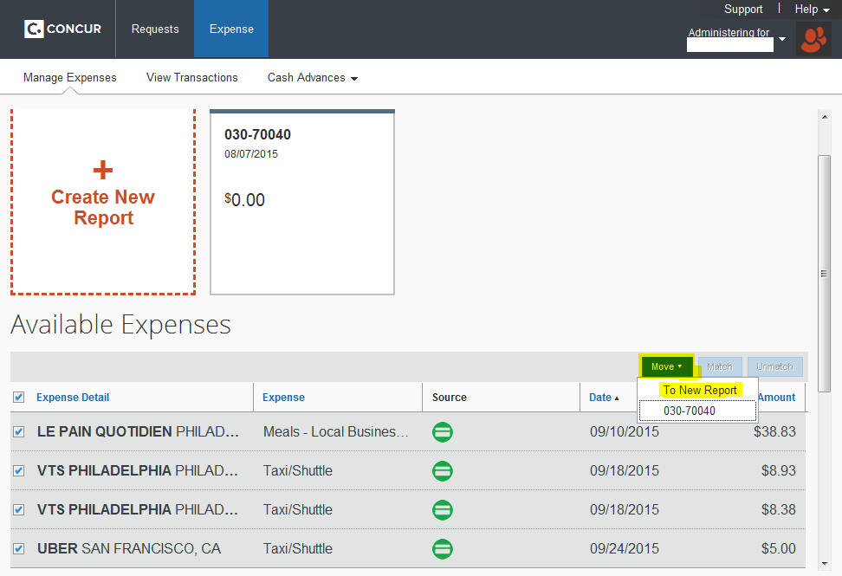
- After selecting the expenses you wish to add to your expense report, click Move∇ and then To New Report.
  - You may also add these expenses to an open report. Open reports will appear below To New Report.
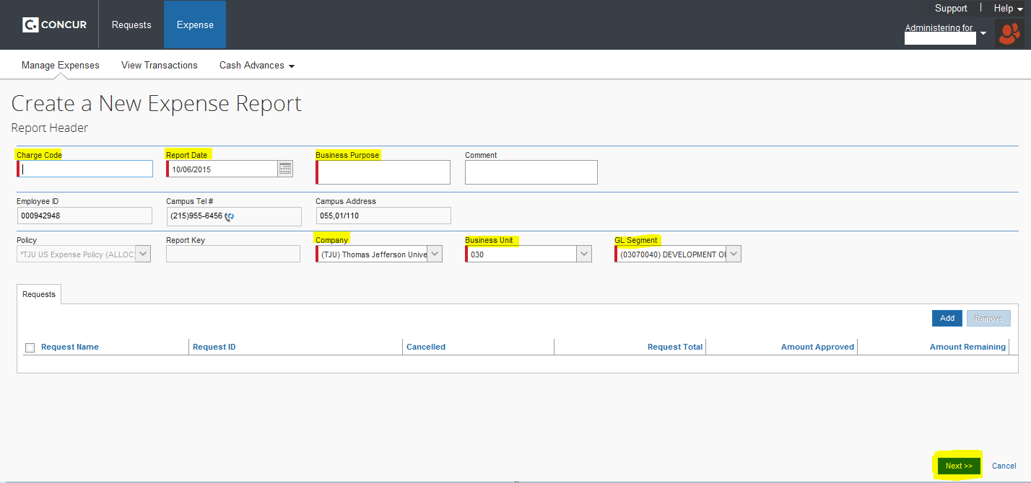
- Enter the Report Header information, making certain that the Company, Business Unit and GL Segment fields are representative of the departmental cost center against which the expenses should be charged.
- Click Next >>

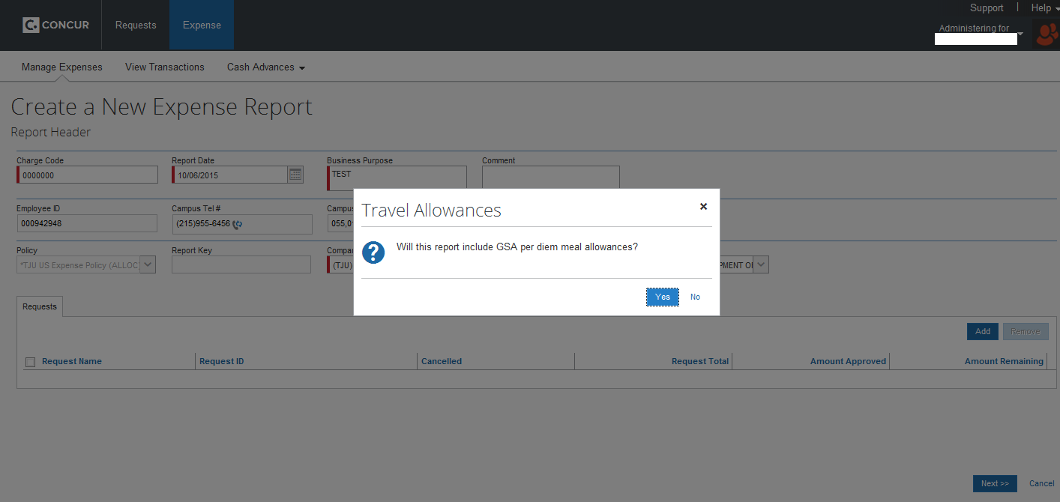
- Indicate if you would like to add per diem meals to your expense report

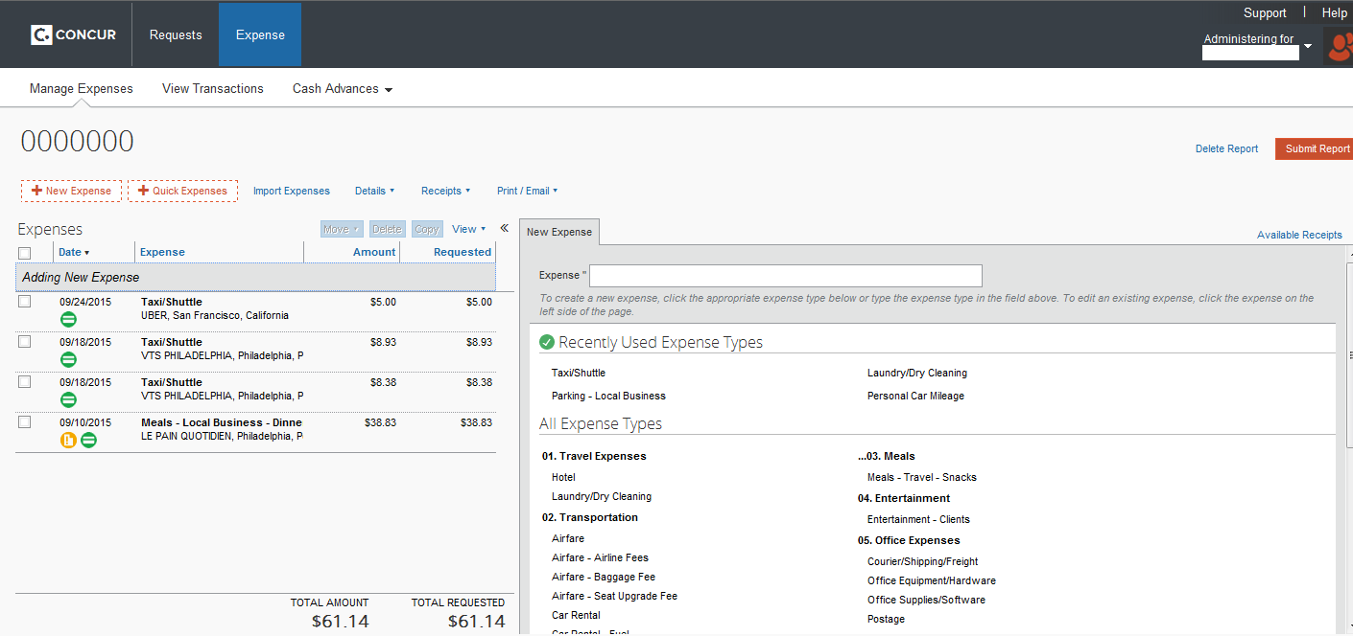
- The American Express card charges will appear in the expense report, inclusive of all available information.
  - You may notice a red exclamation point, indicating that additional information is required.
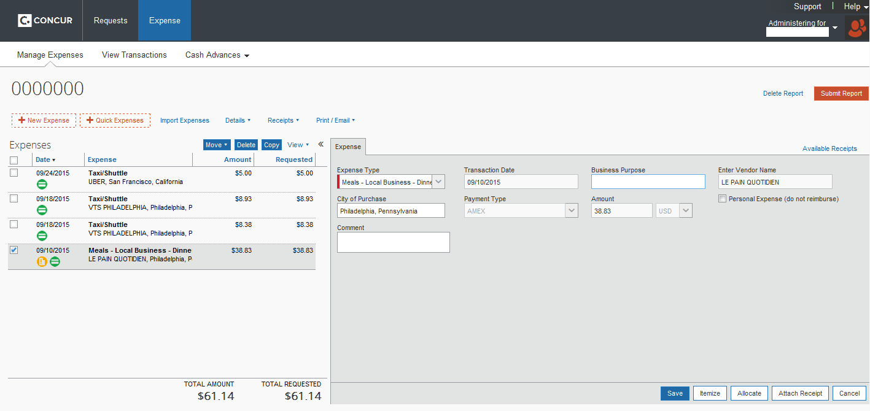
- Attach receipts by clicking on the expense from the menu on the left.
  - Then, click Attach Receipt and browse Concur or your computer to find the appropriate image.
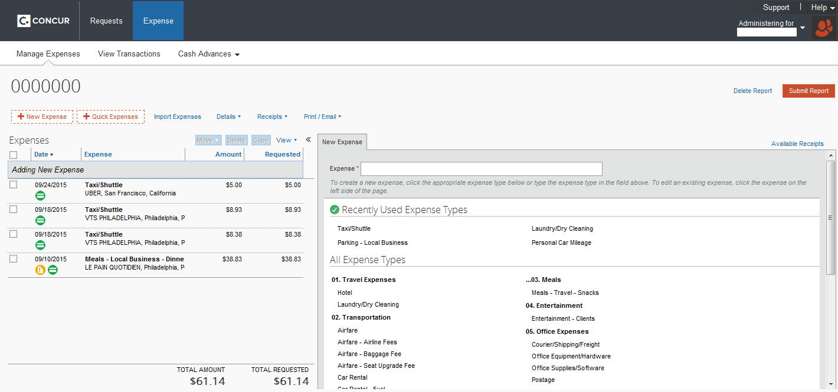
- If you have other, non-American Express expenses to add to your report, click + New Expense and select the appropriate expense type from the menu on the right.
  - Enter the required information and click Save
If any personal or unapproved business expenses were charged to a corporate American Express card, Cardholder is responsible for making payment directly to American Express.
Payments must be mailed to the address below. Please include an account number reference on the memo line so American Express will know how to apply the payment.
American Express Travel
PO Box 360001
Fort Lauderdale, FL 33336-0001

